Supplementary figures and tables to

**“Rapid and continuing regional decline of butterflies in eastern Denmark 1993-2019”**

byBjerregård, Emil Blicher; Baastrup-Spohr, Lars; Markussen, Bo; Bruun, Hans Henrik

## Appendix 1: Delimitation of localities

**FIGURE S1** Example of site delineation. The site Gribskov is outlined in blue, encompassing contiguous (plantation) forest and natural areas, i.e. non-farmland and non-urban. Neighbouring forest areas are marked in red, separated from Gribskov by farmland. Source of orthophotos: GeoBasis-DE/BKG, TerraMetrics.

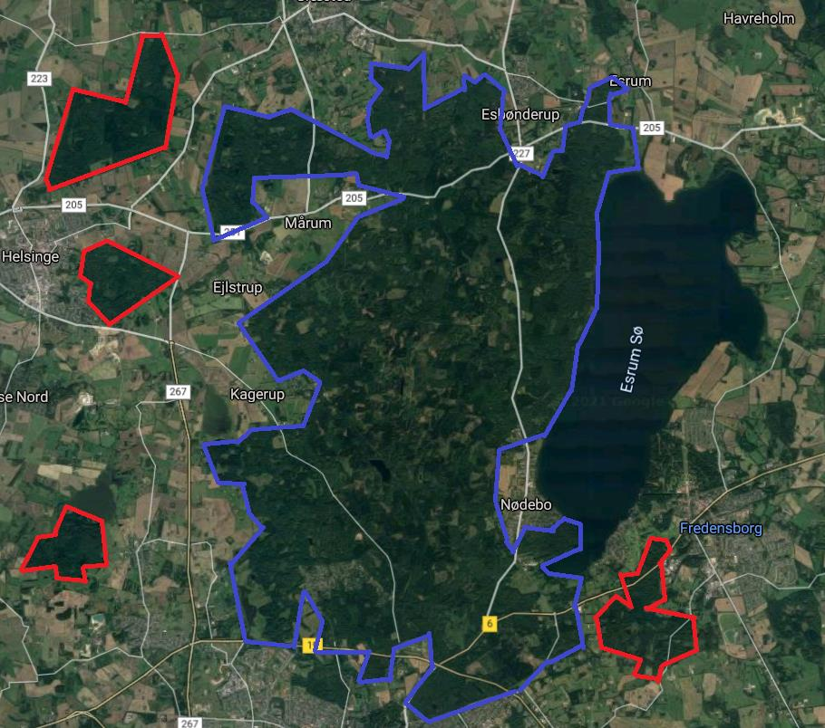

**FIGURE S2** Example of delineation of sites representing different habitat types. These were treated as separate sites, despite being physically contiguous. The coastal grassland site Melby Overdrev is outlined in red, the (plantation) forest Tisvilde Hegn is outlined in blue, the inland grassland site Tibirke Bakker is outlined in green, and the (willow swamp) forest Ellemose is outlined in purple. Source of orthophotos: GeoBasis-DE/BKG, TerraMetrics.

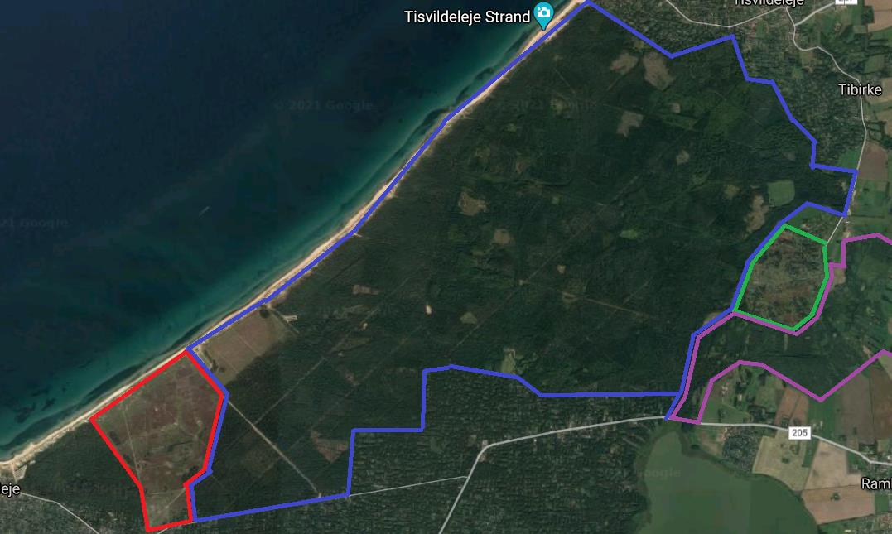

## Appendix 2: Examples of recent major land-use change in Eastern Denmark leading to local extinction of butterfly populations

**FIGURE S3** Vassingerød Old, Northeast Zealand: 55°50'09.7"N 12°20'16.1"E. Habitat for *Lycaena hippothoe* and *Polyommatus amandus* until 2013. The area was used extensively as military training ground for several decades and, as such, not under legal nature protection. In 2006, the area was acquired by a golf club and converted into a golf course. The left-hand aerial photo from 2004 shows the area in the final years as military training ground. The right-hand aerial photo shows the area in 2020, 13 years after the golf course was established. Source of orthophotos: GeoBasis-DE/BKG, TerraMetrics.

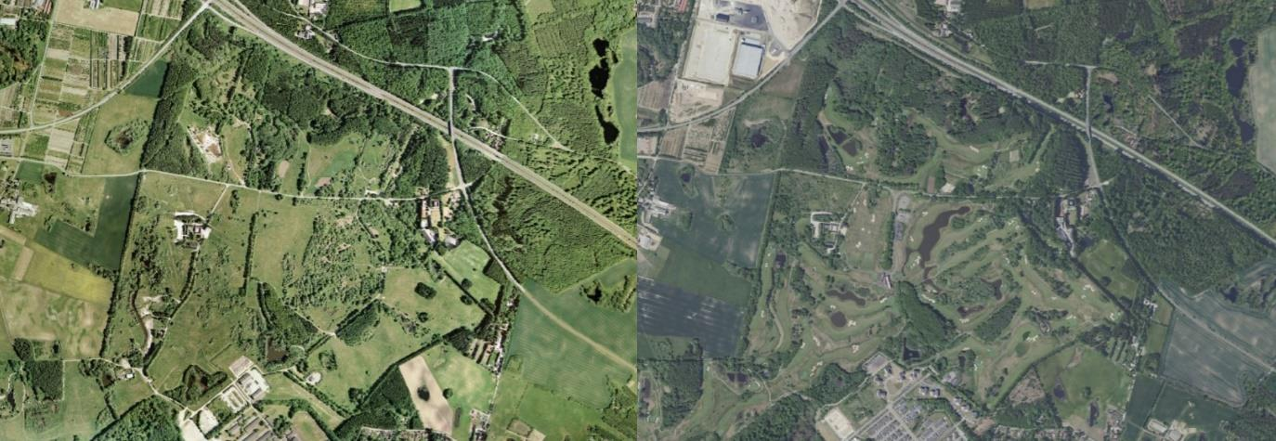

**FIGURE S4** Skansebakken, North East Zealand: 55°56'00.7"N 12°20'21.8"E. Habitat for *Cyaniris semiargus* until 1993, *Polyommatus amandus* until 2003 and *Boloria selene* until 2007. Blue polygons indicate unbuilt areas and red polygons mark the areas after it was built. On the left picture is a satellite photo from 1995, a few years before the site was built on and on the right picture is a satellite photo from 2020, 25 years later. Lycaena hippothoe is still present at Skansebakken but in much lower numbers than in the 1990’ies. Source of orthophotos: GeoBasis-DE/BKG, TerraMetrics.

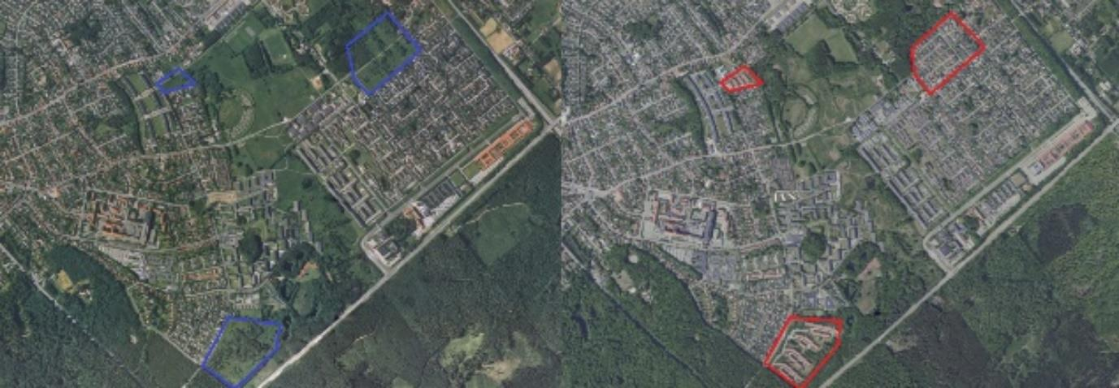

Appendix 3:

Table S1 Input data – attached as csv file

Table S2 Assignment of ADD observations to a standardized set of named sites

Table S3 ADD records omitted because they were considered cases of a stray individuals not representing a population.

|  |  |  |  |  |  |  |
| --- | --- | --- | --- | --- | --- | --- |
| Species name | Site name in ADD | Date | Month | Year | Faunistic district | Serial number |
| *optilete* | Melby Overdrev | 26 | 6 | 89 | NEZ | 105367 |
| *optilete* | Gribskov | 12 | 6 | 90 | NEZ | 123042 |
| *optilete* | Himmelev | 12 | 6 | 90 | NEZ | 114131 |
| *rubi* | Holmegårds Mose | 13 | 6 | 90 | SZ | 119761 |

Appendix 4: Supplementary figures and tables

Figure S5 Trends in occupancy of 19 uncommon butterfly species in Eastern Denmark 1993-2019, with species allocated to broadly defined habitat categories. Units on ordinate axes are identical over all four panels.



Table S4 Fisher’s Exact test investigation *§3* protection across the 13 butterfly species in the open habitats (grasslands and peat bogs). All tests are two-sided. Estimates and 95pct confidence intervals (in brackets) for the odds ratios are all based on two-sided tests. Italics or boldface annotations imply significance on 5pct level within species, and boldface imply significance on 5pct level across species. Both are given with asterisks as visual cues. If all sites with the species present from the starting year had the same legal protection status, then neither odds ratio nor p-value are given.

| Species | **Odds ratio (Yes vs No)** | **p-value** | **Odds ratio (2015 vs 1993)** | **p-value** | **Odds ratio (2019 vs 2015)** | **p-value** |
| --- | --- | --- | --- | --- | --- | --- |
| aglaja | *2.19 (1.06 ; 4.73)* | *0.0239\** | 5.17 (0.62 ; 244.92) | 0.1445 | 4.69 (0.05 ; 467.48) | 0.3715 |
| amandus | **4.1 (2.11 ; 8.29)** | **0.0001\*** | 5.26 (0.7 ; 237.17) | 0.1045 | Inf (0.12 ; Inf) | 0.1765 |
| aquilonaris | Inf (0.45 ; Inf) | 0.1495 | 4 sites with presence in 1993 all protected | NA | 3 sites with presence in 2015 all protected | NA |
| argus | **10.21 (2.43 ; 91.51)** | **0.0001\*** | 1.48 (0.02 ; 125.34) | 1.0000 | 0 (0 ; 271.84) | 1.0000 |
| arion | Inf (0.13 ; Inf) | 0.5163 | 2 sites with presence in 1993 all protected | NA | 1 sites with presence in 2015 all protected | NA |
| armoricanus | 3.47 (0.38 ; 166.54) | 0.4050 | 0 (0 ; 194.41) | 1.0000 | 0 (0 ; Inf) | 1.0000 |
| hippothoe | *2.41 (1.03 ; 6.16)* | *0.0416\** | 0.45 (0.07 ; 2.66) | 0.4382 | 0.4 (0.01 ; 6.51) | 0.6004 |
| idas | **11.25 (2.69 ; 100.44)** | **0.0001\*** | Inf (0.37 ; Inf) | 0.1109 | 19 sites with presence in 2015 all protected | NA |
| malvae | **3.07 (1.48 ; 6.71)** | **0.0011\*** | 2.98 (0.55 ; 31.02) | 0.3069 | 0 (0 ; 30.18) | 1.0000 |
| optilete | **Inf (1.79 ; Inf)** | **0.0035\*** | 11 sites with presence in 1993 all protected | NA | 5 sites with presence in 2015 all protected | NA |
| rubi | **Inf (6.18 ; Inf)** | **0.0001\*** | 29 sites with presence in 1993 all protected | NA | 25 sites with presence in 2015 all protected | NA |
| semiargus | *4.36 (0.93 ; 41.13)* | *0.0487\** | 0 (0 ; Inf) | 1.0000 | 1 sites with presence in 2015 all protected | NA |
| tages | Inf (0.13 ; Inf) | 0.5163 | 2 sites with presence in 1993 all protected | NA | 1 sites with presence in 2015 all protected | NA |

Table S5 Fisher’s Exact test investigation *Natura2000* protection across 18 butterfly species. All tests are two-sided. Estimates and 95pct confidence intervals (in brackets) for the odds ratios are all based on two-sided tests. Italics or boldface annotations imply significance on 5pct level within species, and boldface imply significance on 5pct level across species. Both are given with asterisks as visual cues. If all sites with the species present from the starting year had the same legal protection status, then neither odds ratio nor p-value are given.

| Species | **Odds ratio (Yes vs No)** | **p-value** | **Odds ratio (2015 vs 1993)** | **p-value** | **Odds ratio (2019 vs 2015)** | **p-value** |
| --- | --- | --- | --- | --- | --- | --- |
| adippe | **0.26 (0.09 ; 0.63)** | **0.0010\*** | 0.4 (0.01 ; 3.85) | 0.6549 | Inf (0.01 ; Inf) | 1.0000 |
| aglaja | 1.53 (0.76 ; 3.05) | 0.2408 | *6 (1.23 ; 40.27)* | *0.0175\** | 1.46 (0.02 ; 39.23) | 1.0000 |
| amandus | *1.97 (1.06 ; 3.67)* | *0.0260\** | 2.82 (0.83 ; 10.56) | 0.0978 | 4.49 (0.19 ; 322.88) | 0.5148 |
| aquilonaris | 5.78 (0.45 ; 307.73) | 0.1219 | 0 (0 ; 116.79) | 1.0000 | Inf (0.01 ; Inf) | 1.0000 |
| argus | *3.19 (1.3 ; 8.12)* | *0.0083\** | 0.74 (0.11 ; 4.53) | 1.0000 | Inf (0.25 ; Inf) | 0.1751 |
| arion | Inf (0.35 ; Inf) | 0.1197 | 2 sites with presence in 1993 all protected | NA | 1 sites with presence in 2015 all protected | NA |
| armoricanus | *9.89 (1.08 ; 475.1)* | *0.0201\** | 0 (0 ; 194.41) | 1.0000 | 0 (0 ; Inf) | 1.0000 |
| euphrosyne | 0.53 (0.16 ; 1.44) | 0.2712 | 1.13 (0.02 ; 18.27) | 1.0001 | Inf (0.01 ; Inf) | 1.0000 |
| hippothoe | 1.35 (0.6 ; 2.96) | 0.4501 | 0.61 (0.12 ; 2.81) | 0.5144 | 2.51 (0.15 ; 163.45) | 0.6004 |
| idas | **6.42 (2.54 ; 17.86)** | **0.0001\*** | 2.42 (0.33 ; 18.16) | 0.3905 | 1.31 (0.02 ; 25.74) | 1.0000 |
| ino | 1.1 (0.5 ; 2.36) | 0.8556 | 0.8 (0.16 ; 3.6) | 1.0000 | 1 (0.07 ; 17.3) | 1.0000 |
| malvae | *2.2 (1.13 ; 4.3)* | *0.0151\** | 2.94 (0.82 ; 11.68) | 0.0889 | 4.93 (0.2 ; 352.16) | 0.2451 |
| optilete | 3.5 (0.86 ; 16.9) | 0.0518 | 3.52 (0.17 ; 260.91) | 0.5455 | Inf (0.04 ; Inf) | 0.4000 |
| rubi | **6.42 (2.54 ; 17.86)** | **0.0001\*** | 0.86 (0.01 ; 13.05) | 1.0000 | 0 (0 ; 14.12) | 1.0000 |
| selene | 1.33 (0.72 ; 2.44) | 0.3831 | 1.14 (0.37 ; 3.37) | 0.8057 | 3.37 (0.26 ; 196.35) | 0.3603 |
| semiargus | 1.44 (0.4 ; 4.96) | 0.5660 | 0 (0 ; Inf) | 1.0000 | 1 sites with presence in 2015 all un-protected | NA |
| silvicola | 0.94 (0.02 ; 18.3) | 1.0000 | Inf (0.05 ; Inf) | 0.3334 | 1 sites with presence in 2015 all protected | NA |
| tages | Inf (0.35 ; Inf) | 0.1197 | 2 sites with presence in 1993 all protected | NA | 1 sites with presence in 2015 all protected | NA |