Laboratory incubation method to determine potential ammonia volatilization from soil with fertilizer applied

Lærke Wester-Larsen¹, Dorette Sophie Müller-Stöver¹, Tapio Salo², Lars Stoumann Jensen¹*

¹ Section for Plant and Soil Science, Department of Plant and Environmental Sciences, University of Copenhagen, Thorvaldsensvej 40, 1871 Frederiksberg C, Denmark.
² Water quality impacts, Unit of Natural Resources, Natural Resources Institute Finland, Tietotie 4, 31600 Jokioinen, Finland.
* Corresponding author: lsj@plen.ku.dk

This method was developed to determine whether a fertilizer applied to soil poses risk of ammonia (NH₃) loss under conditions favouring NH₃ volatilization, thus simulating field conditions with high wind speeds and no vegetation cover. The method is a modification of the static diffusion enclosure setup. It was developed from modifying the procedures described in (Husted et al., 1991; Ndegwa et al., 2009; Mandal et al., 2016). The colorimetric method is used to quantify NH₃ in acid traps instead the more commonly used titration method.

Equipment

For each setup, the following equipment is needed:
1 Glass canning jar (0.75 L) with airtight locking lids with rubber caskets
2 plastic shot glasses
1 26 mL airtight plastic container
1 120 mL plastic container with a surface area of 18 cm²
10 mL 1 M NaOH*
5 mL 0.2 M sulfuric acid*
100 g DW of soil/sand
* To be replaced several times during the experimental period.

0.75 L canning jar | Plastic shot glass | 120 mL plastic container | 26 mL plastic container
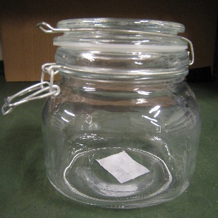 | 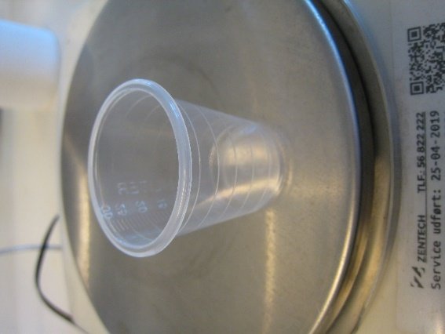 | 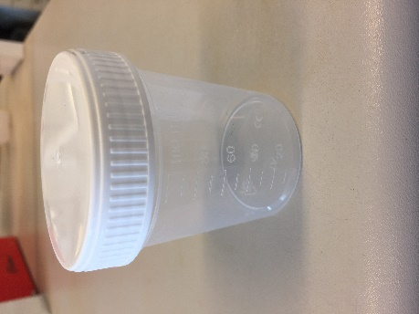 | 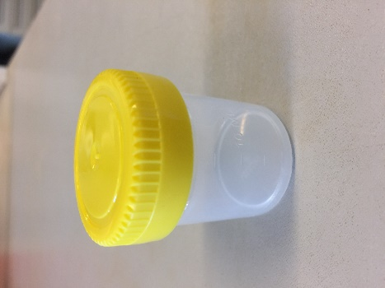

Procedure

Preparations
The setup can be made with either sand or soil or none of them depending on the desired outcome. The sand can be used if the physical properties of a soil are desired without chemical interactions of the soil.
Soil:
Preparing the soil: The soil can be air dry and should be sieved, e.g. to 2 mm or 4 mm. 100 g (dry weight) will be added to each 120 mL container.
Rewetting the soil: Approximately one week before the experiment is started, the soil should be rewetted to a moisture content corresponding to 60 % of water holding capacity (WHC). The Milli-Q water should be added evenly using a pipette to each 120 mL container with soil. As the soil is not completely dry, the gravimetric water content is determined by oven drying for 24 hours at 105 ℃. The amount of water present in the soil should be subtracted from the water that is to be added to obtain 60 % WHC. Moreover, the water added with the liquid BBFs should be subtracted from the amount of water, which is to be added to the soil.
Sand:
As it is not sensible to do WHC determination on sand, the amount of water to be added was estimated by testing different amounts added and assessing the moisture of the sand. It was estimated that for 100 g (dry weight) of size fraction (0.4-0.9 mm), 20 mL of water should be added to the sand to keep it moist. If the sand contains moisture, this moisture should be subtracted from the 20 mL added Milli-Q water.
Chemicals:
Preparing the NaOH solution: A solution of 1M NaOH should be prepared by dissolving 40 g of NaOH pellets in 1 L of Milli-Q water. The NaOH is used to trap CO₂ from the system.
Preparing the ammonium bicarbonate solution: A solution containing 100 mg ammonium bicarbonate (NH₄HCO₃) per mL of Milli-Q water is prepared. In order to apply 0.072 g N, 4.1 mL NH₄HCO₃ should be applied. The NH₄HCO₃ is used as a reference and included in all experimental runs to enable comparisons of different runs.
Preparing the Sulphuric acid: A concentration of sulphuric acid of 0.2 M is used to trap the volatilized NH₃. The selected concentration was based on (Ndegwa et al., 2009; Mandal et al., 2016). The amount of sulphuric acid was calculated stoichiometrically so the sulphuric acid was able to trap the double amount of NH₃ as could possibly volatilize (Ndegwa et al., 2009). 1 mole of sulphuric acid can trap 2 moles of NH₃ according to: H₂SO₄ + 2NH₃ (NH₄)₂SO₄ (Ndegwa et al., 2009). Based on this it was decided to use 5 mL of 0.2 M H₂SO₄ to ensure that the traps we nowhere near to saturation at any point.

Setting up the experiment
Start with preparing all traps and water shot glasses and place them in the canning jar. If you are well prepared, the fertilizer application will take approximately the same amount of time as the exchange of traps afterwards and you can ensure that the trap exchange is done at the same time of the day for all samples. This is especially important when you have many samples.
Acid trap: Add 5 mL of sulfuric acid solution to a plastic shot glass. Place the glass in the canning jar.
CO₂ trap: Add 10 mL of 1M NaOH to a plastic shot glass. Place the glass in the canning jar.
Water: Add approximately 10 mL of demineralised water to a separate plastic shot glass to maintain the soil moisture during the incubation. The glass is placed in the jar.
Applying fertilizer: Apply fertilizer corresponding to 400 kg N ha⁻¹, which corresponds to 0.004 g N cm⁻², or 0.072 g N. Another desired amount can also be used. The soil surface in the 120 mL container is 18 cm².
Fertilizer applied (g) = (0.072 g N * 100) / fertilizer total N %
Incubate: immediately after applying the fertilizer, the lid of the canning jar should be closed airtight. The jars are placed in an incubation cupboard with a constant temperature of 15 ℃, or the desired temperature.

NH₃
CO₂
Fig. 1: Sketch of the setup.

Running the experiment
Prepare new acid trap: Add 5 mL of sulphuric acid to a plastic shot glass.
Prepare new CO₂ trap: Add 10 mL of 1M NaOH to a plastic shot glass.
Replace acid and CO₂ trap: The lid of the canning jar is opened and the acid and CO₂ traps are removed from the jar. The new acid and CO₂ traps are placed in the jar and the lid is closed again immediately after replacing the traps. This will also allow sufficient air exchange to avoid oxygen depletion.
Quantification of NH₃ colorimetrically: The amount of NH₄⁺ in the acid trap is quantified by using flow injection analysis. Water is used as carrier solution and standards are also prepared in water. The samples are diluted with water 1:2, 1:10, 1:100 or 1:500 times depending on the concentration. A standard prepared in 0.2 M H₂SO₄ solution and diluted 1:2, 1:10 and 1:100 times in water, thus comparable to the samples, is included as well to enable comparisons of the standards in water and diluted acid.

These steps are repeated according to the below time schedule.
Sampling schedule:
Sampling no | Day no | Hours after start | Week no
T0 | 0 | 0 | 1
T1 | 1 | 24 | 1
T2 | 2 | 48 | 1
T3 | 5 | 120 | 1
T4 | 9 | 216 | 2
T5 | 14 | 336 | 3
T6 | 20 | 480 | 4
T7 | 27 | 648 | 5
T8* | 35* | 840* | 6*
T9* | 44* | 1056* | 7*
* Sampling points are not necessary.

At the end of the experiment the 120 mL plastic containers with the sample can be weighed to determine if they have lost or gained moisture during the incubation period. Moreover, pH of the sample should be determined by thoroughly mixing the sample and taking out 5 g to determine pH in 1:5 in Milli-Q water.

Setup
Three replicates of each treatment are included. Tests of the setup without any sand/soil or fertilizer are included (blank test) along with controls with only sand/soil and no fertilizer. Moreover, a reference fertilizer of ammonium bicarbonate is included in each batch to enable comparisons between batches.

References
Husted, S., Jensen, L.S., Jorgensen, S.S., 1991. Reducing ammonia loss from cattle slurry by the use of acidifying additives - The role of the buffer system. J. Sci. Food Agric. 57, 335-349.
Mandal, S., Thangarajan, R., Bolan, N.S., Sarkar, B., Khan, N., Ok, Y.S., Naidu, R., 2016. Biochar-induced concomitant decrease in ammonia volatilization and increase in nitrogen use efficiency by wheat. Chemosphere 142, 120-127.
Ndegwa, P.M., Vaddella, V.K., Hristov, A.N., Joo, H.S., 2009. Measuring Concentrations of Ammonia in Ambient Air or Exhaust Air Stream using Acid Traps. J. Environ. Qual. 38, 647-653.

